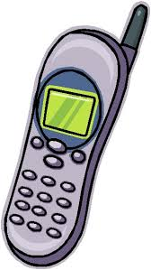

Mobile Phone Contract

I require the use of my mobile phone to ensure my safety to and from school.

- I understand that the use of mobile phones is prohibited during the school day.
- I agree to hand my mobile phone in to the office if requested and to retrieve it from the office after dismissal from class.

Pupil Name: ______________________
Class: ______________
Pupil Signature:_______________________
Parent/Guardian Name:___________________
Parent/Guardian Signature:_______________________
Date: __________

